The Weimar Republic and the Nazis 1924–1929

Study Sources F to J and then answer all parts of the Question. To answer the questions, use the Sources and your own knowledge. In your answers, you should refer to the Sources by their letters.

Top of Form

Source F

The Nazi Party in 1928
Support for the Nazi Party had grown due to the country's problems of hyperinflation and the French invasion of the Ruhr. By 1928 Nazism appeared to be a dying cause. Now that Germany's outlook was suddenly bright, the Nazi Party was rapidly withering away. One scarcely heard of Hitler or the Nazis except as a joke.
from The Rise and Fall of the Third Reich (1959) by William Shirer.
William Shirer was an American journalist who lived in Germany from 1926 to 1941.

Question 1a
Why did the Nazis attract little support in the years 1924 to 1929? Explain your answer using Source F and your own knowledge. (6 marks)

Write your answer here…

Source G  A criticism in 1924 of Stresemann’s policies  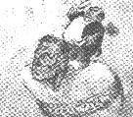  A cartoon published in 1916. | Source H  Germany in 1929  The German economy is doing well only on the surface. Germany is in fact dancing on a volcano. If the short-term loans are called in by America, most of our economy will collapse.  from a speech made by Gustav Stresemann shortly before his death on 3 October 1929

Question 1b
Which source, Source G or Source H, is the more useful to an historian studying the achievements of the Weimar Republic in the period 1924 to 1929? Explain your answer using Sources G and H and your own knowledge. (8 marks)

Write your answer here…

Source I

Unemployment in Germany, 1926-29
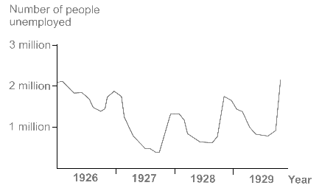
from figures issued by the governments of the Weimar Republic.

Question 1c
Is Source I reliable as evidence about the effects of the economic policies of the Weimar Republic in the period 1924 to 1929? Explain your answer using Source I and your own knowledge. (6 marks)

Write your answer here…

Source J

An interpretation of Stresemann’s achievements, 1924–29
With the death of Stresemann, Germany has lost her ablest leader. He worked hard to rebuild his shattered country and for peace and co-operation abroad. Because of his leadership Germany is now prospering and has an important place in the affairs of Europe.
from The Times, a British Newspaper (4 October 1929).
This is an extract from an account of his life and achievements which was written just after his death.

Question 1d
Does Sources J give an accurate interpretation of the achievements of Stresemann during the period 1924 to 1929? Explain your answer using Source J and your own knowledge. (6 marks)

Write your answer here…

Question 1e
"The Weimar governments were successful in solving Germany's problems between 1924 and 1929."
Do you agree or disagree with this interpretation?
Explain your answer using the Sources and your own knowledge. (10 marks)

Write your answer here…

Bottom of Form

