How to use www.johndclare.net

... for homework

Especially if you do not normally use www.johndclare.net in your lessons, the site provides many excellent opportunities for setting homeworks.

TOP TIP:  even in the most affluent areas, you are going to have pupils who do not have access to the internet to do their web-based homework.  Solutions to this include:  1. provide hard copy materials for those who need (inconvenient for you);  2. provide preferential access (?? at stated times ??) for your pupils to school-based internet facilities (MUCH better).  WHATEVER you decide to do to address this problem, make sure you write to all parents letting them know what facilities you are setting up for the pupils so that they can do their homework. | TOP TIP:  You can get hard copies of many of the materials on this website by clicking on the icon to the left of the title on the web-page. This provides a Word version of the document, which you can print out.

Ideas for Homeworks
Possible ideas for homeworks using www.johndclare.net include:

Basic preparation
Simple cloze notes
Further notes
'Green box' Questions
Smartass sophistication

TOP TIP:
Whatever homework you set, make sure that the pupils clearly understand exactly what they have to do and exactly WHERE THEY HAVE TO GO to access the materials.
Make sure, therefore, that you:
1. SHOW the pupils (either by demonstrating using an interactive whiteboard, or by taking them all through step-by-step clicking together as a class) where the materials are on the www.johndclare.net website,
AND
2. GIVE them the specific URL (do not leave them to write it down - they make mistakes).

One way to ensure idiot-proof access is to post a 'History Homeworks' link page on the school website or VLE.

Basic preparation  Why not ask the pupils to read the 'Basics' leaflet on the topic before you start any work on the topic?  TOP TIP:  Active reading: don't just tell the pupils to 'read the leaflet' (how do you check they have done it properly anyway). Ask them to read the leaflet and make a list of 'questions arising' in their minds from what they have read. It doesn't matter if the questions are simplistic, unhistorical or even irrelevant. The pupil has been forced to interact with the material, and comes to the lessons with an 'agenda for learning'.  Thus you will start your lessons about the topic with pupils who - though they may not understand what they have read - have at least some knowledge of the subject, and arrive at the lessons with things they think they need to find out. | Basic preparation  FAQ: Why bother to read a hard copy version when the text is available on-screen?  Because the written word is more easily appropriated on paper than on-screen.
Simple cloze notes  On each web-page of the www.johndclare.net booklets you will see, to the top left of the title, a icon. If the pupils click on this, they will access a very simple ‘Hot Potatoes’ cloze exercise. This allows even the least able to make neat notes on the topic content, and it is appreciated by the more able pupils as a quick and easy way assuredly to acquire a set of basic notes. | Simple close notes
If you are not using the cloze exercises in your lessons, a very easily-done and accessible homework is to set the pupils to do the cloze exercises at home.  TOP TIP:  Train your pupils – when they do any work on the website – when they have finished, to copy and paste their work into a new Word page before they print or save (i.e. they print or save the Word page).  • For Printing, it allows them to improve layout and save paper;  • For Saving, it ensures that the page saves safely, and that they don’t lose their work.  This is so much easier that trying to teach them a set of procedures so they can print or save from the exercise window itself.  As I collect in the pupils' notes at the end of each topic, I insist that they have AT LEAST done ALL the cloze exercises on the site on the topic. | FAQ: Why make the pupils do the cloze exercises at home?  It makes sense to get the pupils to do the simpler, mindless tasks at home - where they will be working without any help - and to do the harder, skills-rich tasks (such as sourcework and essays) in lessons - where you are there to help them.  I have never been able to understand why so many teachers set the easy tasks in lessons, and then get the pupils to go home to struggle alone with the difficult tasks.
Further Notes  Especially for your more able and more motivated pupils, the www.johndclare.net booklets - with the differentiated lists of links at the top right of every page - provide an excellent opportunity to make further notes on the topic you are studying.  As I collect in the pupils' notes at the end of each topic, I insist that they have AT LEAST done ALL the cloze exercises on the site on the topic, but also insist on seeing evidence of further reading.  TOP TIPS:  1. When you set 'note-making' as a homework, it helps the pupils if you specify either.  • a specific web-page/ item, or:  • a specific 'question'  to help them focus their note-taking.  2. Train the pupils to start off each set of notes by putting as a title the author and the book they are noting.  3. Pupils usually need reminding that the idea of notes is to write down NEW facts and ideas that they hadn't come across before, and not already-known facts and ideas that they are comfortable with. | Further Notes

'Green box' questions  At the bottom of every page of the www.johndclare.net booklets you will find ‘the green box questions’: | 'Green box' questions
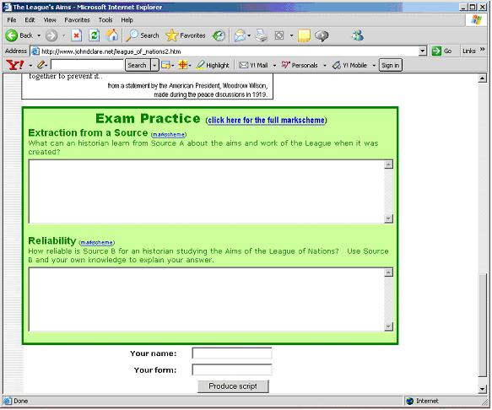
The ‘green box questions’ ask exam-style questions – specifically, the kinds of question the pupil will meet on that AQA Paper, although they are appropriate for ANY GCSE board – and provide a ‘box’ for the pupils to type their answer into. Teachers may wish to define the 'time-to-be-spent' as a guideline.

TOP TIP:
Make sure the pupils have done some of these questions in class - so they know how the exercises 'work’ - before you set them as a homework.

If you have not done these questions in class, to set them as a homework is an excellent exercise, which provides the pupils with practice in the exact answer-skills they will need to answer the questions they will meet in the examination. NB that by clicking on the ‘Markscheme’ links, the pupils are able to gain access to generic markschemes for each kind of question, and thus remind themselves of how to score the highest marks possible.

Also - since it is presented as a typed print-out - the pupils' work is much easier to mark than hand-written answers!

TOP TIP:
Instead of setting all the different kinds of question on one web-page, why not set the pupils to do a number of the SAME KINDS OF QUESTION (e.g. Reliability questions) from a number of different web-pages?

Smartass Sophistication  Many pupils are CLEVER enough, but they express their ideas in a non-academic way, using non-academic terms (and this depresses their marks).  One of the features of the website are the 'Smartass' lists of topic-technical terms.  Although primarily designed as a revision tool, the Smartass lists provide a homework opportunity. If you decide to try this, DO NOT set the pupils to learn the whole list; set the homeworks like the pupils used to be set their 'spellings' homeworks at Primary School - so many (depending on ability) per week, with a spelling/meaning test in the lesson. | Smartass sophistication

