The Russian Civil War, 1918–21

Study Sources A to E and then answer all parts of the Question. To answer the questions, use the Sources and your own knowledge. In your answers, you should refer to the Sources by their letters.

Top of Form

Source A

Opposition to the Bolsheviks in the Russian Civil War
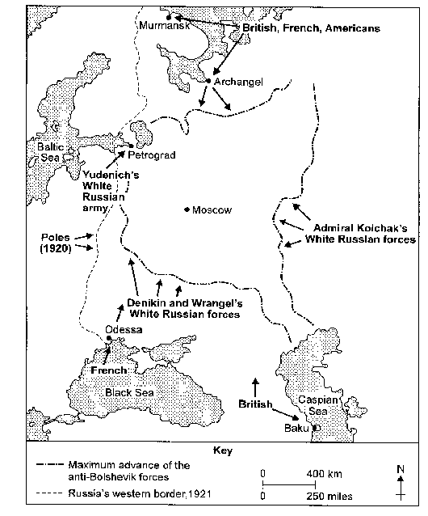
from Russia and the USSR (1995), by Alan White, a textbook was written for use in British schools.

Question 1a
What made the Whites such a threat to the Bolsheviks in the Civil War? Explain your answer using Source A and your own knowledge. (6 marks)

Write your answer here…

Source B

An account of Bolshevik ruthlessness
Right from the start the Red Army killed all the White officers they took prisoner. They shot them or cut their medals off and gouged out their chests.
from the memoirs of George Novikoff, a White Russian, written in the late 1980s.

Source C

A view of the Whites and the Allied Powers
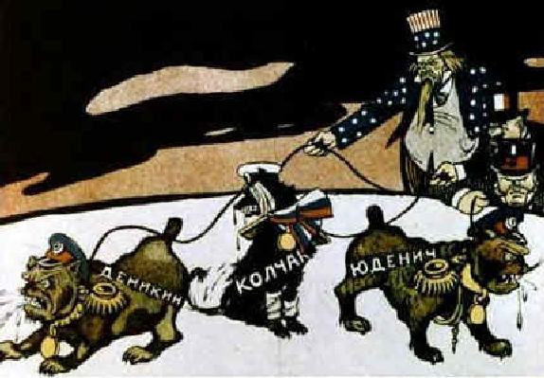
A Bolshevik poster of the time.
The names written on the dogs are Denikin, Kolchak and Yudenich. The three men in the background represent the USA, France and Britain.

Question 1b
Is Source B more useful than Source C to an historian studying the Civil War? Explain your answer using Sources B and C and your own knowledge. (8 marks)

Write your answer here…

Source D

An interpretation of the Civil War
The Communist Party sent the best of its members to join the Red Army. By the end of 1918 the Red Army numbered 1,700,000. It was a strong force. Even so, on every battlefront Red Army units had to fight against an enemy who was better equipped, better trained and who outnumbered them.
from History of the USSR (1981) by Y Kukushkin, a Soviet historian.

Question 1c
In Source D is Kukushkin reporting facts or giving opinions? Explain your answer using Source D and your own knowledge. (5 marks)

Write your answer here…

Source E

An interpretation of the Civil War
From the winter of 1918-19 even Kolchak and Denikin faced a struggle against great odds. The Bolsheviks had had a year to strengthen their position. They controlled most of the resources of old Russia. They had more popular support, and their forces outnumbered those of the Whites by 10 to 1.
from The Russian Civil War (1987), by E Mawdsley, a British historian.

Question 1d
Sources D and E were both written by historians but give very different interpretations of the Civil War. Why do you think their interpretations differ? Explain your answer using Sources D and E and your own knowledge. (7 marks)

Write your answer here…

Question 1e
"The Bolshevik success in the Civil war was due to the weaknesses of the Whites."
Do you agree or disagree with this interpretation?
Explain your answer using the Sources and your own knowledge. (10 marks)

Write your answer here…

Bottom of Form

