The Impact of Industrialisation and the 5-Year Plans, 1928–41

Study Sources A to E and then answer all parts of the Question. To answer the questions, use the Sources and your own knowledge. In your answers, you should refer to the Sources by their letters.

Top of Form

Source A

Motives for industrialisation
If we are backward and weak, we may be beaten and enslaved. But if we are powerful, people must beware of us. We are 50 to 100 years behind the advanced countries of the West. We must make up this gap in 10 years. Either we do this or they crush us.
from a speech made by Stalin to the First Conference of Workers in 1931)

Question 1a
Why did Stalin want to modernise Soviet industry? Explain your answer using Source A and your own knowledge. (6 marks)

Write your answer here…

Source B
Women and industrial growth
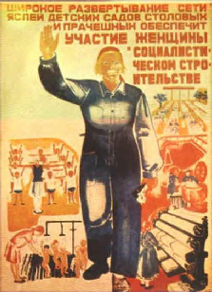
A poster issued by The Soviet Government in 1931.

The poster says that more nurseries, laundries and canteens mean that women can take part in industrial growth.

Source C

Working conditions in the city of Magnitogorsk in the early 1930s
In early April it was still bitterly cold, everything was frozen. By May the city was swimming in mud. Plague had broken out not far away. People were in poor health because of lack of food and overwork. Sanitary conditions were appalling. By the middle of May the heat had become intolerable.
from Behind the Urals (1942) by John Scott.
John Scott was an American engineer who voluntarily went to Russia in the 1930s to help in the building of the country.

Question 1b
Which source, Source B or Source C, is more useful to an historian studying Stalin's policy of industrialisation? Explain your answer using Sources B and C and your own knowledge. (8 marks)

Write your answer here…

Source D

Soviet industrial production figures, 1921–40
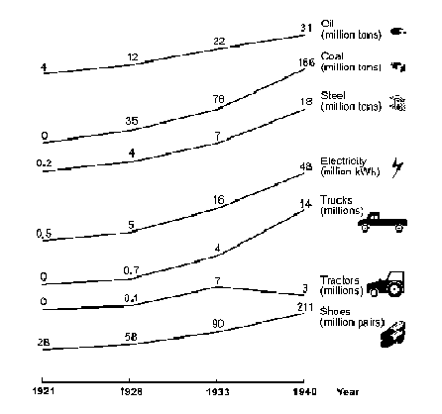
This chart is based on official Soviet statistics.

Question 1c
Is Source D reliable as evidence about the effects of the Five-Year Plans on Russian industrial production? Explain your answer using Source D and your own knowledge. (6 marks)

Write your answer here…

Source E

The Soviet people and industrialisation
The Soviet people achieved so much in such a short time. This happened because all the country's wealth belongs to the working people who create this wealth. The Stakhanovite movement spread all over the country. Thousands of workers produced more that their quota. Miracles were created by the enthusiastic work of the Soviet people.
from a Soviet school textbook published in 1976..

Question 1d
Does Source E give an accurate interpretation of the impact of industrialisation on Russia in the period 1928–40? Explain your answer using Source E and your own knowledge. (6 marks)

Write your answer here…

Question 1e
"Stalin's policy of industrialisation was a success in the period 1928 to 1941." Do you agree or disagree with this interpretation? Explain your answer using the Sources and your own knowledge. (10 marks)

Write your answer here…

Bottom of Form

